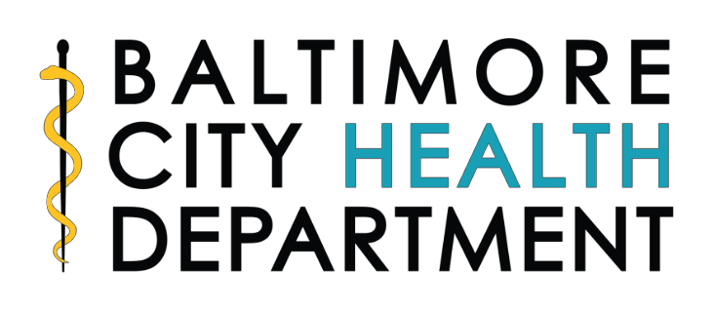

REQUEST FOR APPLICATIONS (RFA)
Title: COVID-19 Operational Support

Funding: Mixed Source Federal

Baltimore City Health Department,
Division of Covid Administration/Operations

Release Date: Monday February 16, 2023
Application Due: March 23, 2023 by 5:00pm EST
Anticipated Award Notification: April 6, 2023
Anticipated Contract Start: May 1, 2023

- Introduction
This Request for Applications (RFA) is to secure a vendor to provide customizations, support, and maintenance for the Lab Web Portal used by and Baltimore City Health Department (BCHD) is the recipient of both American Rescue Plan Act funding and Federal Emergency Management Agency funding to support its response to the COVID-19 emergency. BCHD is releasing this request for applications (RFA) to obtain professional services to support BCHD’s effort to provide COVID-19 testing, particularly in underserved communities by providing a support to an application used in COVID-19 testing activities.

- Applicant Eligibility
BCHD will consider applications from any vendor with the following experience:
- Five or more years of experience in Electronic Test Order and Result
- LIMSConnect Interface configuration and maintenance
- Lab Web Portal configuration and maintenance
- Interoperability and maintenance
- Configuration of LIMS & 3rd party interfaces
- Test requisition Forms configuration and maintenance
- HIPAA compliant
- 24/7 Support

- Scope of Work
The selected vendor will have expertise in Lab Web Portal applications to facilitate electronic test order and results (“ETOR”) exchange for the Baltimore City Health Department. LWP relies on LIMSConnect, a smart data synchronization service developed by iConnect, to synchronize test orders and results between the LWP and Baltimore’s Laboratory Information Management System (LIMS). The selected vendor will provide the following subscription and support services for existing LWP:

Subscription Services
- Establish a hosting environment for the client instance of the LWP in compliance with the security requirements listed in the Agreement;
- Accept laboratory or test orders from requesting facilities via the LWP electronic requisition forms;
- Accept laboratory or test orders from requesting facilities via the LWP batch order templates (if applicable);
- Accept laboratory or test orders from requesting facilities’ Electronic Medical Record (“EMR”) system using the LIMSConnect (if applicable);
- Route any laboratory or test order information to Client using the LIMSConnect;
- Publish any test order result from Client for the requesting facility in the LWP using the LIMSConnect;
- Route any test order result from Client to the requesting facility’s EMR system via the LWP using the LIMSConnect (if applicable);
- Store and allow user access to historic ETOR data in accordance with Client’s reasonable data retention requirements for such ETOR data;
- Collect and allow user access to epidemiologic information reasonably requested by Client;
- Allow direct patient access to view their results (if applicable);

Support Services
- Includes annual support, maintenance and upgrades.
- Help desk and level of support with related notification, response and resolution timeframes based on established Service Level Agreement terms
- Security Monitoring and Maintenance; Security related active real time monitoring, response and notification.

- Application Checklist
- Description of Organization
- Scope of Work
- Detailed Budget
- Letter of Support (2 maximum)
- Evidence of Good Standing with State of Maryland
- Provide a list of any legal action taken against your organization,
- Organizational Chart
- Resume/CV for principal lead(s)

- Availability of Funds
- The award is subject to the availability of appropriated funds and any modifications or additional requirements that may be imposed by city policies and/or regulations.
- Funding for this project is limited to $250,000 over a 20-month period starting on May 1, 2023 and ending on December 31, 2024.
- If an organization is seeking an indirect cost rate, it can be no greater than 10%, unless the organization already has a federal negotiated NICRA.

- Attachment to the RFA
- Budget Templates
  - BCHD Budget Form Instructions
  - BCHD 432 A-I Budget Form
  - BCHD Budget Narrative Form 433
- Example contract – Applicants are expected to review language and share any concerns on language, specifically the ARPA terms and conditions, with BCHD PRIOR to submitting a grant application

Questions from Applicants:
Please email questions to asiya.kyomugisha@baltimorecity.gov by March 2, 2023. All questions received by BCHD will be included on a master question and answer document and posted on BCHD’s website.

Health Department Office:
The program office is located at 1001 E. Fayette Street.

